Estimating Calculations …
… with significant figures

For each calculation here, work out an approximation by rounding to 1 significant figure. You must not use a calculator for this bit! Then use a calculator to work out the real answer. Think whether your answer is close enough to suggest that your workings are correct. Leave the last column blank for now.

Calculation | Approximation | The real answer
6.05 × 12.82

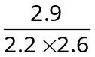

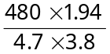

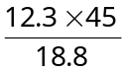

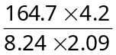

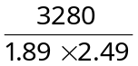

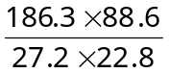

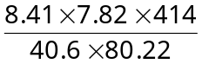

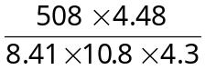

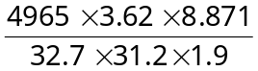

Use the last column to calculate the percentage error in your calculations.

